Add a Fee Schedule Item

Function: A fee schedule item assigns a specific fee to a specific procedure code within a specific fee schedule. The user can defines several fees per procedure code based on the fee schedule the Fee Schedule Item is linked. For example, procedure code 99213, could be $55.00 for a fee schedule defined as a primary care fee schedule and $85.00 for a fee schedule defined as Urology fee schedule. The user is able to assign this in the Add-a-Fee Schedule Item Dialogue.
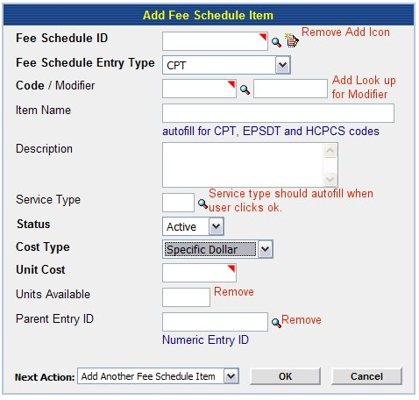
Add:
- Look up for modifier.
- Format example for unit cost (1.00 or 1. or 1)
Remove:
- Add icon at Fee Schedule ID
- Remove units available
- Remove Parent Entry ID

Description of Fields
Fee Schedule ID: This is the ID of the Fee Schedule that is being linked to this procedure code at the specified unit cost.
Fee Schedule Entry Type: (aka Procedure code) This is the type of code that is being added to a fee schedule. The current drop down is sufficient: CPT, HCPCS, EPSDT, and Misc. Code
Code: This is the specific procedure code.
Modifier: If the user has different unit costs, based on the modifier, they may set up multiple unit costs.
Item Name: The user assigns the name of the procedure in this field.
Description: This field describes the procedure. Currently, in Physia, it auto fills the description from the CPT, HCPCS, EPSDT or the description given at creation of Miscellaneous code. The user can edit this field and free text a shorter or more familiar description of the code. This is a nice feature.
Service Type: This is based on HCFA guidelines for Service Type for Procedure codes. This should auto fill for user but they may edit service type or add it for misc codes.
Status: This allows the user to deactivate a fee schedule item.
Cost Type: This allows the user to define the cost by a certain value or a formula. Remove “multiple of a group, Multiple of RVU and UCR 75%”
Unit Cost: The amount for procedure code or the rate of calculation, based on Cost type.
Next action: Where the user wants to go once they complete dialogue.
Ok: Saves entry.
Cancel: Escapes entry without saving.

Action Codes

Look up Fee Schedule ID: This look up takes user to a search engine for an existing Fee schedule. The user should be able to pull up using the following criteria:
Fee Schedule Name, Fee Schedule ID, Description, Physicians linked to Fee Schedule, Locations linked to Fee schedule
Fee Schedule Name
Fee Schedule ID | **User enters ID * look up for ID
Description
Associated Physicians | **User enters ID(s)* look up for ID
Associated Site Organizations | **User enters ID(s) * look up for ID

Once user clicks [OK]→application pulls up results:

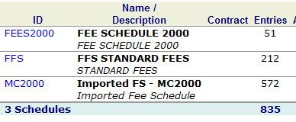

- User clicks look up→application takes user to search engine→user clicks Name/Description (Fee Schedule 2000)→application takes user to details of fee schedule
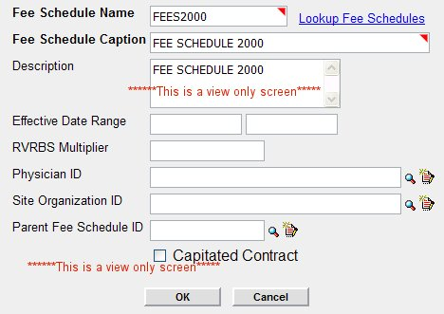
This is a view only screen. →User closes screen→application takes user back to results→user chooses existing Fee Schedule by clicking hyperlink on Fee Schedule ID→application closes results window→application auto fills Fee Schedule ID in Add a Fee Schedule Item dialogue.

Lookup for CPT Code
The look up should offer the following constraints:
Code type (i.e. HCPCS, CPT etc)
Code name
Code description

Search results should pop up in another window:
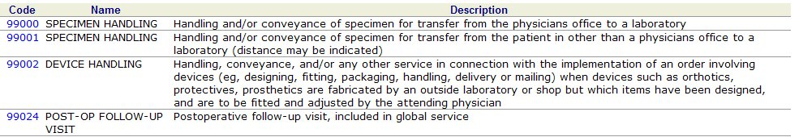

If the user selects the code→application should close window→place code in a blank field at CPT in the Add-a-Fee Schedule Item dialogue.

***Note: User does not need to look up Code; they should be able to key it in if they know it.

Look up Modifier
This should be a simple Look up for Modifiers.
It should constrain by either code or name. (Is it possible to make search engine for Reference codes and user can use a drop down to choose what kind of reference code they are looking to use?)

Search results should pop up in another window:
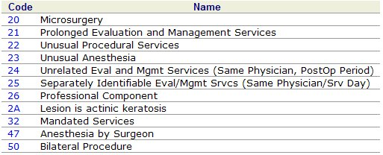
**Historically, these are listed in numerical order.

If the user selects the code→application should close window→place code in a blank field at Modifier in the Add-a-Fee Schedule Item dialogue.

***Note: User does not need to look up Code; they should be able to key it in if they know it.

Look up Service Type
This should be a simple Look up for Service type.
It should constrain by either code or name.

Search results should pop up in another window:
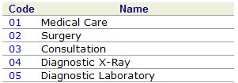
**Historically, these are listed in numerical order.

If the user selects the code→application should close window→place code in a blank field at Service Type in the Add-a-Fee Schedule Item dialogue.
***Note: User should not have to enter this, in most cases. The application should auto fill this when user clicks ok. The user should only have to enter it when the application cannot find it in the table. Physia used to do this. It no longer does.

Next Action:

Once the user completes all necessary fields in Add-a-Fee Schedule Item Dialogue, they should choose a Next Action (see below)
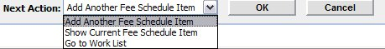

Add:
- View Fee Schedule Item
- Go to Search
- Return to Home
- Go to Fee Schedule Catalog
Remove:
Show Current Fee Schedule Item

Add Another Fee Schedule Item: Takes user to blank dialogue for Add-a-Fee Schedule Item
View Fee Schedule Item: Takes user to summary for Fee Schedule Item
Go to Search: Takes user to Search engine for Fee Schedule items
Return to Home: Takes user to their Home Page
Go to Fee Schedule Catalog: Takes user to Catalog for Fee Schedules
Go to Work List: Takes user to Work List

Function:

User Clicks [OK] → Application adds Fee Schedule Item→ Application performs Next Action.

